Date 17/04/2021 P Certificate Serial Nomef: 69392142.chafford GB ELECTRICAL.

# Electrical Installation Condition Report

(Requirements for Electrical Installations -BS 7671 IET Wiring Regulations)

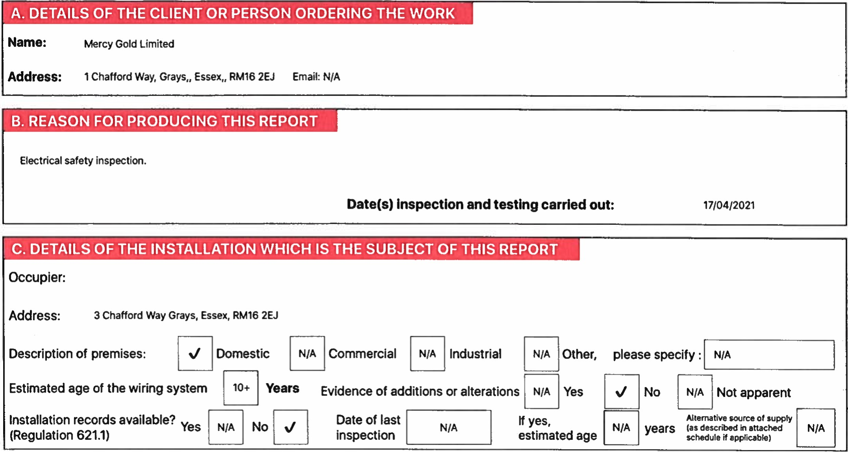

|  |  |  |
| --- | --- | --- |
| D. EXTENT AND LIMITATIONS OF INSPECTION AND TESTING carried The inspection out in accordance and testing with dctatted BS 7671 in this as amendedreport and accompanying schedutcs have been | | |
| Extent of the electrical installation covered by this report Electrical lighting and power circuits.  Agreed limitations including the reasons, see Regulations 653.2  No inspection of concealed cable.  Llmltetions agreed with Landlord. Position (if applicable) N/A  Operational limitations  NIA including the reasons  tt should be noted that cables concealed within trunking and corWuits. under floors, in roof spaces, and generally within the fabric of the building or underground, have not been inspected unless specifically agreed between the client and inspector prior to the inspection. An inspection should be made within accessible roof space housing other electrical equipment. | | |
| E. SUMMARY OF THE CONDITION OF THE INSTALLATION | terms of Its suitability for continued use:  SATISFACTORY  and/or potentially dangerous (code C2) conditions have been identified | |
| General condition of the installation (in terms of electrical safety)  Good  Overall assessment of the installation In  An unsatisfactory assessment Indicates that dangerous (code Cl) |

This report Js based on the model forrns shown in Appendix of BS 7671 (as amended)

Produced using Certifi electrical certificates. www.'certifi.co.uk Pagel of 9

|  |  |
| --- | --- |
| F. RECOMMENDATIONS | of the suitability of the installation for continued use on page 1 is stated as UNSATISFACTORY, I/we classified as 'Danger present' (Code Cl) or 'Potentially dangerous' (Code C2) are acted upon as a without delay is recommended for observations Identified as 'Further Investigation required' (Fl) 'improvement recommended' (Code C3) should be given due consideration.  action being taken, llwe recommend that the installation is further inspected and tested by 16/04/2024 |
| Where the overall assessment recommend that any observations matter of urgency. Investigation  Observations classified as  Subject to the necessary remedial |



|  |  |  |  |  |  |  |  |  |  |  |  |  |  |  |  |  |  |  |  |  |  |  |  |  |  |  |  |
| --- | --- | --- | --- | --- | --- | --- | --- | --- | --- | --- | --- | --- | --- | --- | --- | --- | --- | --- | --- | --- | --- | --- | --- | --- | --- | --- | --- |
| G. DECLARATION  l/We. being the person(s) below), particulars of hereby declare that the assessment of the condition | | | | responsible for the Inspection and testing of the electrical Installation (as indicated by my/our signature(s) which ere described above, having exercised reasonable skill end care when carrying out the Inspection and testing.  Information in this report, Including the observations and the attached schedules, provides an accurate of the electrical installation taking Into account the stated extent and limitations in section D of this report. | | | | | | | | | | | | | | | | | | | | | | | |
|
| INSPECTED AND TESTED BY:  Name  N.  (CAPITALS) Khan  Signature  Position Supervisor Date 17/04/2021  Contact Tel +44 7510615022  Email gbeIectrica1786@gmail.com  Web | | | | | | | | | | | | REPORT AUTHORISED  Contractor  Address  Name  Signature  ENROLMENT NO  (If applicable) | | | | | | FOR ISSUE BY:  GB ELECTRICAL.  127 Woodland Road llford Essex IGI  N. Khan  603686 | | | | | Date | 17104/2021 | | | |
| H. SCHEDULES The attached schedule(s) are part of this document and this report is valid only when they are attached to it | | | | | | | | | | | | | | | | | | | | | | | | | | | |
|  | | | | | N/A | | Schedule(s) of inspection and | | | | | | N/A | | | Schedule(s) of test results attached | | | | | | | | | | | |
| l. SUPPLY CHARACTERISTICS AND EARTHING ARRANGEMENTS | | | | | | | | | | | | | | | | | | | | | | | | | | |
| Earthlng  Arangements(s) | | | Number   |  |  | | --- | --- | | v' | | | NIA | | | NIA | | | | and Type of Live  AC  1 phase  (2 wire)   |  | | --- | | NIA |   2 phase  (3 wire)   |  | | --- | | N/A |   3 phase  (3 wire) | | | Conductors   |  |  | | --- | --- | | NIA | | | NIA | |  |  | | --- | | NIA |   1 phase  (3 wire)   |  | | --- | | NIA |   3 phase  (4 wire) | | DC   1. wire 2. wire   Other | Nature of Supply  Nominat voltage  Nominal frequency  PFC  Ipf (1,2)  External loop impedance  Note   1. by enquiry 2. by enquiry or by | | | 230  50  1.50  .85 measurement | | | Parameters  Volts  Hz  n | | Over current  BS (EN)  Type  Rated current  Short circuit capacity | | Characteristics of Primary  Protective Device(s)  LIMITED  NIA  NIA  NIA | | | | | |
|  | TN-C-S  TN-C | |
| NIA |
| NIA |
| NIA |
| NIA | Confirmation of Supply Polarity | | | | | | | |
|  |
| J. PARTICULARS OF INSTALLATION REFERRED TO IN THIS REPORT | | | | | | | | | | | | | | | | | | | | | | | | | | |
| Distributor's facility  Means | | | | | | | | | | Type N/A Resistance to earth NIA | | | | | | | | | | | | | | | | |
| of earthlng  NIA Installation earth electrode | | | | | | | | | | Location of the earth electrode N/A | | | | | | | | | | | | | | | | |
| MAIN PROTECTIVE CONDUCTORS (to extraneous conductive parts) | | | | | | | | | | | | | | | MAIN SWITCH/SWITCH-FUSE/CIRCUIT BREAKER/RCD | | | | | | | | | | | |
| Earthing Conductor  Conductor Material  Conductor  2  Csa mm  Connection/ verified | | Copper  16   |  | | --- | | N/A | | | | | Main protective bonding conductor  Conductor  Copper Material  Conductor2 10  Csa mm  Connection/ continuity verified | | | Maln Bonding   |  | | --- | | NIA |  |  | | --- | | NIA |   Water  Structural installation steel pipes  GasOther installation  (specify) pipes   |  | | --- | | NIA |   Oil installation pipes | | | | | | Type BS (EN)  No of poles  Supply  Conductor  Conductor csa mm 2  • If RCD main | | | | | 60947 type B  2  Copper  16  switch | | Voltage rating  Current Rating  *Rated time delay  *Rated RCD  Operating current  *RCD Operating time | | | 230  100  NIA  NIA  NIA | ms  mA  ms |

GB ELECTRICAL. Completed using icertifi electrical certificates for iOS Page 2 of 9

69392142.chafford

|  |  |
| --- | --- |
| Referring to the attached schedules of inspection and test results, and subject to the limitations specified at the Extent and Limitations of the inspection and testing section   |  | | --- | | N/A |   No remedial action is required The following observations are made  ITEM NO OBSERVATION CLASSIFICATION CODE |
|  |
| |  |  |  | | --- | --- | --- | | N/A | Additional observations Additional notes/observations attached or to follow ref: | NIA |   One of the following codes, as appropriate, has been allocated to each of the observations made above to indicate to the person(s) responsible for the Installation the degree of urgency for remedial action. |
| Cl Danger present. Risk of injury. Immediate remedial action required |
| C2 Potentially dangerous - urgent remedial action required |
| C3 - Improvement recommended |
| Fl - Further investigation required without delay |

Completed using iCertifi electrical certificates for iOS 30f 9

69392742.chaffo.d

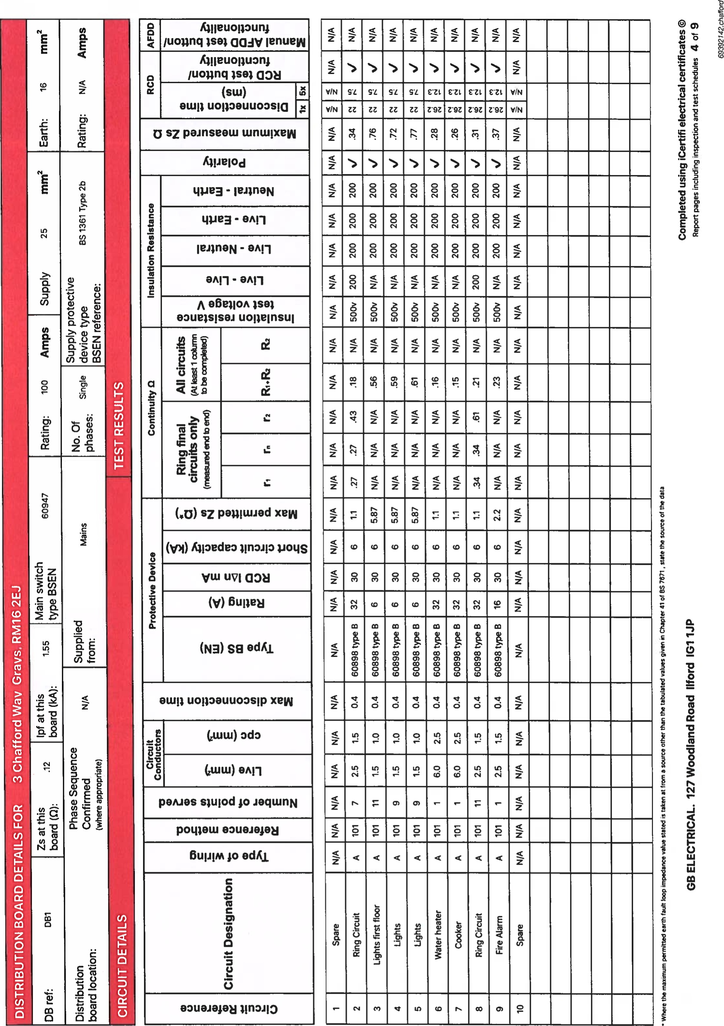

|  |  |  |
| --- | --- | --- |
| Earth fault loop impedance  Insulation resistance NIA  Continuity N/A | TEST  INSTRUMENTS  RCD NIA  MFT N/A  Other NIA | |
| Inspected by:  Signature |  | Name  N. Khan  (CAPITALS)  Date of  1710412021 inspection |
|  | | | |
| Engineers optional Images of Cl or C2 observations if applicable | | | |

## ELECTRICAL. 5 Of 9

|  |  |  |  |  |  |  |  |  |
| --- | --- | --- | --- | --- | --- | --- | --- | --- |
| N. INSPECTION SCHEDULE FOR A DISTRIBUTION BOARD INSTALLATION | | | | | | | | |
| Outcomes | | Acceptable Condition | Unacceptable condition Cl or C2 | Improvement recommended C3 | Further investigation: Fl | Not Verified: | Limitation:  LIM | Not Applicable: NIA |
| ITEM | DESCRIPTION | | | | | | OUTCOME  codes •bow •ddith«u' cunnwnt why• Cl. C2. C3 FI co&d itu•n• to b' •n Sectioa X of ROM) | |
| 1.0 | DISTRIBUTOR'S I SUPPLY INTAKE EQUIPMENT (VISUAL INSPECTION ONLY) | | | | | | | |
| 1.1 | Condition of service cable | | | | | |  | |
| 1.2 | Condition of service head | | | | | |  | |
| 1.3 | Condition of distributor's earthlng arrangement | | | | | |  | |
| 1.4 | Condition of meter talls - Distributor/Consumer | | | | | |  | |
| 1.5 | Condition of metering equipment | | | | | |  | |
| 1.6 | Condition of isolator (where present) | | | | | | NIA | |
| 2.0 | PRESENCE OF ADEQUATE ARRANGEMENTS FOR OTHER SOURCES SUCH AS MICROGENERATORS  (551.6; 551.7) | | | | | | NIA | |
| 3.0 | EARTHING AND BONDING ARRANGEMENTS (411.3, Chapter 54) | | | | | | | |
| 3.1 | Presence and condition of distributor's earthing arrangement (542.1.2.1; 542.1.2.2) | | | | | |  | |
| 3.2 | Presence and condition of earth electrode connection where applicable (542.1.2.3) | | | | | | NIA | |
| 3.3 | Provision of earthlng/bondlng labels at all appropriate locations (514.13) | | | | | |  | |
| 3.4 | Adequacy of earthlng conductor size (542.3, 543.1.1) | | | | | |  | |
| 3.5 | Accessibility and condition of earthlng conductor at MET (543.3.2) | | | | | |  | |
| 3.6 | Adequacy of maln protective bonding conductor sizes (544.1) | | | | | |  | |
| 3.7 | Condition and accesslbllity of main protective bonding conductor connections (411.3.1.2; 543.3.2; 544.1.2) | | | | | |  | |
| 3.8 | Accesslblllty and condition of other protective bonding connections (543.3.1; 543.3.2) | | | | | |  | |
| 4.0 | CONSUMER UNIT OR DISTRIBUTION BOARD | | | | | | | |
| 4.1 | Adequacy of working space I accessibility to consumer unit I distributlon board (132.12; 513.1) | | | | | |  | |
| 4.2 | Security of fixing (134.1.1) | | | | | |  | |
| 4.3 | Condition of enclosure(s) In terms of IP rating etc (416.2) | | | | | |  | |
| 4.4 | Condition of enclosure(s) In terms of fire rating etc (421.1.201; 526.5) | | | | | |  | |
| 4.5 | Enclosure not damaged or deteriorated so as to Impair safety (651.2) | | | | | |  | |
| 4.6 | Presence of maln linked switch (as required by 462.1.201) | | | | | |  | |
| 4.7 | Operation of maln switch - (functional check) (643.10) | | | | | |  | |
| 4.8 | Manual operation of circuit breakers and RCDs to prove disconnection (643.10) | | | | | |  | |
| 4.9 | Correct Identification of circuit details end protective devices (514.8.1; 514.9.1) | | | | | |  | |
| 4.10 | Presence of RCD six-monthly test notice at or near consumer unit/distrlbution board (514.12.2) | | | | | |  | |
| 4.11 | Presence of non-standard (mixed) cable colour waming notice at or near consumer unit I distribution board 514.14 | | | | | | NIA | |
| 4.12 | Presence of alternative supply warning notice at or near consumer unit I distribution board (514.15) | | | | | | NIA | |
| 4.13 | Presence of other required labelling (please specify) (Section 514) | | | | | | NIA | |
|  | | | | | | | | |

## CB ELECTRICAL. 6 Of 9

69392142.chaffQd

|  |  |  |  |  |  |  |  |  |
| --- | --- | --- | --- | --- | --- | --- | --- | --- |
| N. INSPECTION SCHEDULE FOR A DISTRIBUTION BOARD INSTALLATION | | | | | | | | |
| Outcomes | | Acceptable a  Condition | Unacceptable condition Cl or C2 | Improvement recommended C3 |  | Not Verified:  NV | Limitation:  UM | Not Applicable: NIA |
| ITEM | DESCRIPTION | | | | | | OUTCOME  codes  Cl. C2, C3 md Fl itm. to be reorded in K 08 Rep«t) | |
| 4.14 | Compatibility of protective devices, bases and other components; correct type and rating (No signs of unacceptable thermal damage, arcing or overheating) ( 411.3.2; 411.4; 411.6; 411.6; Sections 432, 433) | | | | | |  | |
| 4.15 | Single-pote switching or protective devices In line conductor only (132.14.1; 530.3.3) | | | | | |  | |
| 4.16 | Protection agelnst mechanical damage where cables enter the consumer unit or distribution board (132.14.1; 522.8.1; 522.8.5; 522.8.11) | | | | | |  | |
| 4.17 | Protection against electromagnetic effects where cables enter consumer unit I distribution board I enclosures 521.5.1 | | | | | |  | |
| 4.18 | RCD(s) provided for fault protection - Includes RCBOs (411.4.204; 411.5.2; 531.2) | | | | | |  | |
| 4.19 | RCD(s) provided for additional protectlon/requirements - Includes RCBOs (411.3.3; 415.1) | | | | | |  | |
| 4.20 | Confirmation of Indication that SPD Is functional (651.4) | | | | | |  | |
| 4.21 | Confirmation thet ALL conductor connections. Including connections to busbers, are correctly located In terminals and are tight and secure (526.1) | | | | | |  | |
| 4.22 | Adequate where a generating set operates as a switched alternative to the public supply (551.6) | | | | | |  | |
| 4.23 | Adequate arrangements where a generating set operates In parallel with the public supply (551.7) | | | | | |
| 5.0 | FINAL CIRCUITS | | | | | | | |
| 5.1 | Identification of conductors (514.3.1) | | | | | |  | |
| 5.2 | Cables correctly supported throughout their run (521.10.202; 52208.5) | | | | | | LIM | |
| 5.3 | Condition of the Insulation of live parts (416.1) | | | | | | LIM | |
| 6.4 | Non-sheathed cables protected by enclosure In conduit, ducting or trunking (521.10.1) To Include the Int rit of conduit and trunklng systems (metallic and plastic) | | | | | | NIA | |
| 6.5 | Adequacy of cables for current-carrying capacity with regard for the type and nature of installation Section 523 | | | | | | NIA | |
| 6.6 | Coordination between conductors and overload protective devices (433.1; 533.2.1) | | | | | |  | |
| 5.7 | Adequacy of protective devices: type and rated current for fault protection (411.3) | | | | | |  | |
| 6.8 | Presence and adequacy of circuit protective conductors (411.3.1; Section 543) | | | | | |  | |
| 5.9 | Wiring system(s) appropriate for the type and nature of the installation and external Influences (section 522) | | | | | |  | |
| 5.10 | Concealed cables installed In prescribed zones (see Section D. Extent and limitations) (522.6.202) | | | | | | LIM | |
| 5.11 | onceae ca es ncorpora ng eart e armourors eat , or runw n eart e w ng system, or otherwise protected against mechanical damage from nails, screws and the like (see Section D. Extent and limitations 522.6.204 | | | | | | LIM | |
| 5.12 | Provision of additional requirements for protection by RCD not exceeding 30 mA | | | | | | | |
| * | For all socket-outlets of rating 32 A or less, unless an exception Is permitted (411.3.3) | | | | | | NIA | |
|  | For the supply of mobile equipment not exceeding 32 A rating for use outdoors (411.3.3) | | | | | | NIA | |
| * | For cables concealed In walls et a depth of less than 50 mm (522.6.202; 522.6.203) | | | | | | LIM | |
|  | For cables concealed In wallslpartitions containing metal parts regardless of depth (522.6.203) | | | | | | UM | |
|  | Final circuits supplying luminaires within domestic (household) premises (411.3.4) | | | | | | NIA | |
| 6.13 | Provision of fire barriers, sealing arrangements end protection against thermal effects (Section 527) | | | | | |  | |
| 5.14 | Band Il cables segregated or separated from Band I cables (528.1) | | | | | | NIA | |
| 5.15 | Cables segregated or separated from communication cabling (528.2) | | | | | | LIM | |
| 5.16 | Cables segregated or separated from non-electrical services (528.3) | | | | | | UM | |

## GB ELECTRICAL. 7 Of 9

69392142.chaffo,d

|  |  |  |  |  |  |  |  |  |
| --- | --- | --- | --- | --- | --- | --- | --- | --- |
| N. INSPECTION SCHEDULE FOR A DISTRIBUTION BOARD INSTALLATION | | | | | | | | |
| Outcomes | | Acceptable Condition | Unacceptable condition Cl or C2 | Improvement recommended C3 | Further investigation: Fl | Not Verifled:  NV | Limitation:  UM | Not Applicable: NIA |
| ITEM | DESCRIPTION | | | | | | OUTCOME  cod" •UitW•l cunn•at where Cl. C2, C3 Fl coed to bo recorded K ot CmdiUM Rep«t) | |
| 6.17 | Termination of cables et enclosures — Indicate extent of sampling in Secdon D of the report (Section 626) | | | | | | | |
|  | Connections soundly made and under no undue strain (526.6) | | | | | |  | |
|  | No basic Insulation of a conductor visible outside enclosure (526.8) | | | | | |  | |
|  | Connections of live conductors adequately enclosed (526.5) | | | | | |  | |
|  | Adequately connected at the point of entry to enclosure (glands, bushes etc) (522.8.5) | | | | | |  | |
| 5.18 | Condition of accessories Including socket-outlets, switches end Joint boxes (651.2(v)) | | | | | |  | |
| 5.19 | Suitability of accessories for external Influences (512.2) | | | | | |  | |
| 5.20 | Adequacy of working space/accessibllity to equipment (132.12; 513.1) | | | | | |  | |
| 6.21 | Single-pole switching or protective devices In line conductors only (132.14.1, 530.3.2) | | | | | |  | |
| 6.0 | LOCATION(S) CONTAINING A BATH OR SHOWER | | | | | | | |
|  | Additional protection for all low voltage (W) circuits by RCD not exceeding 30 mA (701.411.3.3) | | | | | |  | |
| 6.2 | Where used as e protective measure, requirements for SEW or PELV met (701.414.4.5) | | | | | | NIA | |
| 6.3 | Shaver sockets comply with BS EN 61558-2-5 or BS 3535 (701.512.3) | | | | | |  | |
| 6.4 | Presence of supplementary bonding conductors, unless not required by BS 7671:2018 (701,415.2) | | | | | |  | |
| 6.5 | Low voltage (e.g. 230 volt) socket-outlets sited at least 3 m from zone 1 (701,512.3) | | | | | | NIA | |
| 6.6 | Sultabllity of equipment for external Influences for installed tocatlon In terms of IP rating (701.512.2) | | | | | |  | |
| 6.7 | Suitability of equipment for Installation In a particular zone (701.512.3) | | | | | |  | |
| 6.8 | Suitability of current-using equipment for particular position within the location (701.55) | | | | | |  | |
| 7.0 | OTHER PART 7 SPECIAL INSTALLATIONS OR LOCATIONS | | | | | | | |
| 7.1 | List all other special Installations or locations present, If any ('Record separately the results of particular Inspectlons applied) | | | | | |  | |
|  |  | | | | | |  | |
|  |  | | | | | |  | |
|  |  | | | | | |  | |

'Special installations or locations present, if any. Details of circuits and/or installed equipment vulnerable to damage when testing and/or remarks

GB ELECTRICAL. Page8 of 9

æ392142chaffa•d

# CONDITION REPORT GUIDANCE FOR RECIPIENTS

(to be appended to the report)

This report is an important and valuable document which should be retained for future reference

Notes for the person producing the report

1. The purpose of this Condition Report is to confirm, so far as reasonably practicable, whether or not the electrical installation is in a satisfactory condition for continued service (see Section E). It should not be used for the replacement of a consumer unit/distribution board. The Report should identify any damage, deterioration, defects and/or conditions which may give rise to danger (see Section K).
2. The person ordering the Report should have received the "original" Report and the inspector should have retained a duplicate.
3. The Report should be retained in a safe place and be made available to any person inspecting or undertaking work on the electrical installation in the future. If the property is vacated, this Report will provide the new owner/occupier with details of the condition of the electrical installation at the time the Report was issued.
4. Where the installation incorporates a residual current device (RCD) there should be a notice at or near the device stating that it should be tested six monthly. For safety reasons it is important that this instruction is followed.
5. Section D (Extent and Limitations) should identify fully the extent of the installation covered by this Report and any limitations on the inspection and testing. The inspector should have agreed these aspects with the person ordering the Report and with other interested parties (licensing authority, insurance company, mortgage provider and the like) before the inspection was carried out.
6. Some operational limitations such as inability to gain access to parts of the installation or an item of equipment may have been encountered during the inspection. The inspector should have noted these in Section D.
7. For items classified in Section K as Cl ("Danger present"), the safety of those using the installation is at risk, and it is recommended that a skilled person competent in electrical installation work undertakes the necessary remedial work immediately.
8. For items classified in Section K as C2 ("Potentially dangerous"), the safety of those using the installation may be at risk and it is recommended that a skilled person competent in electrical installation work undertakes the necessary remedial work as a matter of urgency.
9. Where it has been stated in Section K that an observation requires further investigation (code F!) the inspection has revealed an apparent deficiency which may result in a code Cl or C2, and could not, due to the extent or limitations of the inspection, be fully identified. Such observations should be investigated without delay. A further examination of the installation will be necessary, to determine the nature and extent of the apparent deficiency (see Section F).
10. For safety reasons, the electrical installation should be re-inspected at appropriate intervals by a skilled person or persons, competent in such work . The recommended date by which the next inspection is due is stated in Section F of the Report under 'Recommendations' and on a label at or near to the consumer unit/distribution board. It is recommended that a competent person undertakes the necessary remedial work immediately.
11. Any deficiencies with intake equipment should be reported to the person ordering the work

|  |  |  |  |  |  |  |  |
| --- | --- | --- | --- | --- | --- | --- | --- |
|  |  |  |  |  |  |  |  |
|  |  | c |  |  |  |  | Reference Methods are methods of installation for which the current-carrying capacity has been determined by test or calculation |
| PVC/PVC CABLES | PVC  CABLES IN  METALUC  CONDUIT | PVC  CABLES IN NON. METALLIC  CONDUIT | PVC  CABLES IN  METALLIC TRUNKNG | PVC CABLES IN NON.  METALLIC TRUNKNG | PVC/SWA CABLES | XLPEISWA CABLES |

This from is based on the model forms of BS 7671 Page 9 of 9

693921